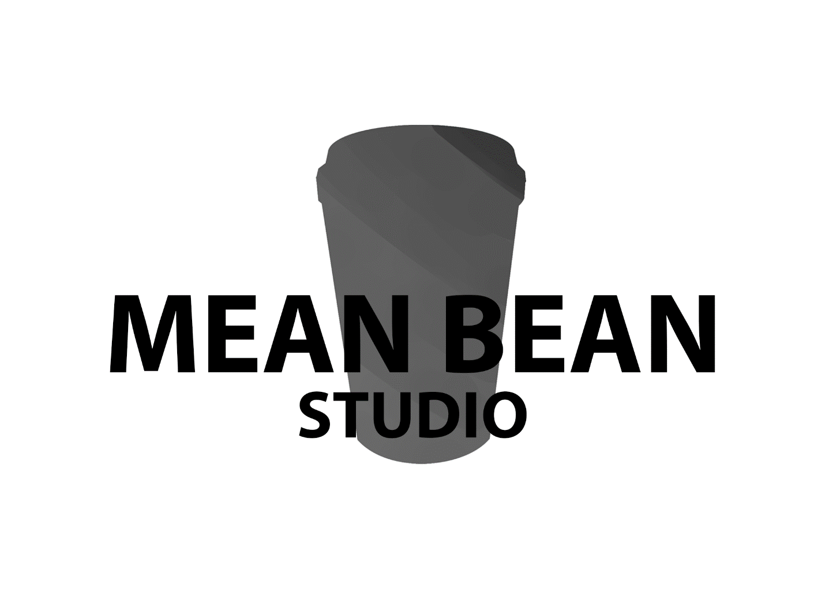

Luke, Will, Aiden, Domenic, Pasqual, Tarek

**Client synopsis**

The client has made it clear that the following needs to be in the game

1. The game should be
   1. Exciting
   2. Positive
   3. Upbeat
   4. Dynamic
2. The game should focus on
   1. Traveling
   2. Collecting experiences
3. End with an amazing cup of coffee

**Project scope**

Due to the amount of time the scope of the project will be small. Even though we have a team of six we are experimenting with new tasks such as map generation which will take time to make.

**Genre**

In terms of genre we decided to do a 3D endless runner. This fits within our projects scope of being simple, it also allows the option for both phone and PC an option that we can give to the client.

**Target platform**

Although we would like to make the game for the phone there is a risk in terms of art and programming being different. The team was not confident with this and the decision was made to switch to **pc**.

**Target market**

The target audience as the client has said are “young, adventurous, who enjoy the fine things in life.”

The app will mainly be targeting people at the age range of 16 to 45 years with more focus on high school – university students (GenZ) and other young adults (Gen Y). Studies show that 61% of GenZ and 53% of GenY drink coffee, this is followed by GenX with 36%. This study was done in Australia.

<https://mccrindle.com.au/insights/blogarchive/australian-attitudes-towards-coffee/>

**Competitor analysis**

* Temple run
* Sonic dash
* Subway surfers

Although all three are similar to the game we’re making none of them offer real life rewards. Al of them offer in game purchases including currency and skins**.** The difference these games are the lane systems, in sonic dash and Subway surfers the player has to **swipe the screen** to change lanes while temple run has a **tilt system**.

Our game was going to have the tilt system if we were going to make the game on a phone.

However, the decision is available for the client.

**Project approval process**

Communication is key, we have the clients email, if we have an idea that affects the sales of their coffee we will email them immediately to get their confirmation. Visa versa, when it comes to the specifics of the values the client meetings will be the perfect opportunity to sort out all of the client details.

**Aiden Thiele:**

**Skills:**

3D modelling (Proficient with Zbrush and Maya)

Texturing (Hand painted and done though substance painter)

Lighting (Creating lighting passes in engine)

Concepting (Proficient in creating rough sketches and concepts)

**Duties:**

Environment artist (Building and texturing assets for the levels)

Assisting with lighting or completing main lighting passes

Assistance with sound design

(Can work with animations in some scenarios)

**Responsibilities:**

I have the responsibility to ensure that environment art is up to par and that it serves the level design seamlessly.

I have a duty to create assets to the best of my ability to fulfill whatever request is presented.

I have a responsibility to serve the group to the fullest to ensure our success.

|  |  |
| --- | --- |
| Strength | Weakness |
| 3D modelling and sculpting | Character animation |
| Texturing of assets | Over scoping |
| Lighting environments | Trying to ensure things are perfect |
| Hard working | Can have self-destructive work habits |
| Quick learner | Can become distracted with new concepts |
| Able to problem solve | Will try and find the correct method to solve issues even if it can cost some extra time |

**Tarek Waleed:**

**Skills:**

3D modelling: Can make anything in Maya.

Animating: Can rig and animate in Maya

Texturing: Can texture models in substance painter

Concepting: Can do concepting in photoshop but I’m not the best at it

**Duties:**

Rigging and Animating

**Responsibilities:**

I have the responsibility to create rigs and animation without any errors

|  |  |
| --- | --- |
| Strength | Weakness |
| Maya | zbrush |
| Texturing | May lose motivation |
| Rigging and Animating | Tired almost everyday |
| Unity and Unreal engine | Not good with documents, especially very long ones |

**William Tjang**

**Skills**

* C++ programming
* C# programming
* Unity development

**Duties**

* Coding the tile/map generation function
* Coding a share of the player pickup mechanics
* Coding a local leaderboard generator

**Responsibilities**

* Create a script which endlessly generates tiles until the player dies and ensure that a set of rules are followed such it is always possible for the player to pass any point. E.g. Obstacles are not stacked together so that is impossible for the player to pass.
* Ensure each of the pickup mechanics work as intended.
* Create a code which saves the leaderboard onto a file that is stored locally on the player’s computer.

|  |  |
| --- | --- |
| Strength | Weakness |
| Coding mechanics | Coding complex AIs |
| Maths calculation | Documentation |
| Knowledge of Unity functions/features | Pre-planning |
| Debugging | Tendency to overscope |

**Domenic Nastasio**

**Skills:**

3D modelling (in Maya and Zbrush)

Texturing (in substance painter)

Concepting (hand drawing is my strongest)

**Duties:**

Work on character designs

Making sure there able to be used to be animated

**Responsibilities:**

I have the responsibilities of making sure the characters are spot on and how everyone envisioned of them.

Helping out with assets for the game so we can make sure we get done by the deadline.

|  |  |
| --- | --- |
| Strength | Weakness |
| 3D modelling and sculpting | Texturing |
| Zbrush and Maya | Skin weighting |

**Pasqual Fletcher**

**Skills:**

* C++ programming
* C# programming
* Unity development

**Duties:**

* The player character control scripts
* The Menu and user interface scripts
* Half the player pickups

**Responsibilities:**

* I have the responsibility to create the scripts to allow control of the players character, the scrips for the menu and UI as well as some of the pickups.
* I have the responsibility to ensure the player character is responsive and feels good to control. To make sure the menu, UI and character pickups work correctly.

|  |  |
| --- | --- |
| Strength | Weakness |
| Unity | Documentation |
| C# | AI |
|  |  |
|  |  |

**Luke Kasper:**

**Skills:**

Level design (creating an engaging experience for the player)

Narrative design (creating a story)

Mechanic design (designing fun interesting mechanics for the game)

Basic level of programming in c#

**Duties:**

Pattern creation (making a set of rules that the game generation must follow)

Ensuring everyone works a as a team

Creating a fun experience for the player

**Responsibilities:**

* I have the responsibility to ensure that the client is satisfied with our game as well has having a positive player reaction.
* I have a duty to ensure that the team works cohesively.
* I have the responsibility to ensure that our game meet the clients want while creating a fun and engaging experience for the player

I have a responsibility to serve the group to the fullest to ensure our success.

|  |  |
| --- | --- |
| Strengths | Weakness |
| Problem solving | Written communication |
| Level design | Time efficiency |
| Documentation | Group efficacy |
| Understanding people |  |
| Verbal communication |  |

**Development environment**

Team programs

* Project tracking: Trello- to track tasks and see who has completed what
* Git Kraken: this is our source control
* Communication: Slack
* Unity: the engine the team is using.

Art programs

* Maya
* Z brush
* Substance
* Photoshop